Q1:

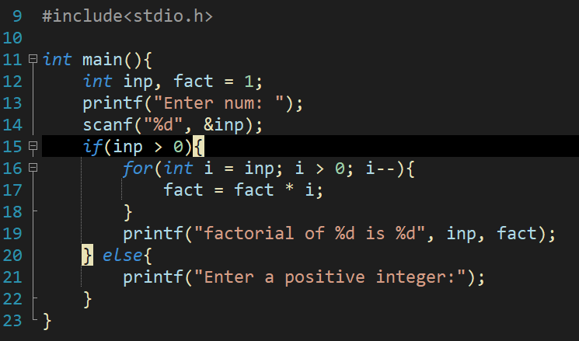

#include<stdio.h>

int main(){

int inp, fact = 1;

printf("Enter num: ");

scanf("%d", &inp);

if(inp > 0){

for(int i = inp; i > 0; i--){

fact = fact * i;

}

printf("factorial of %d is %d", inp, fact);

} else{

printf("Enter a positive integer:");

}

}

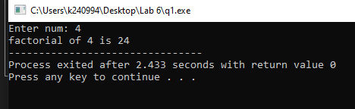

Q2:

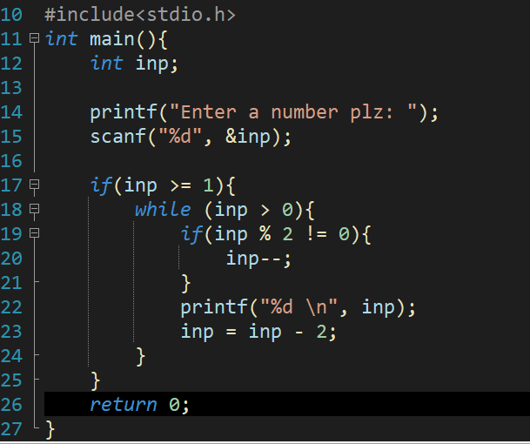

#include<stdio.h>

int main(){

int inp;

printf("Enter a number plz: ");

scanf("%d", &inp);

if(inp >= 1){

while (inp > 0){

if(inp % 2 != 0){

inp--;

}

printf("%d \n", inp);

inp = inp - 2;

}

}

return 0;

}

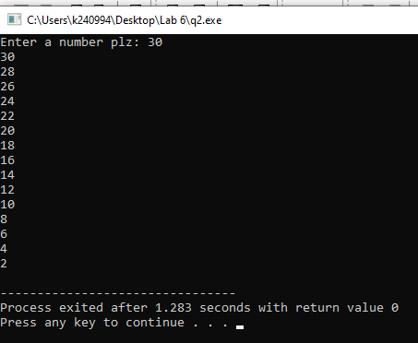

Q3:

#include<stdio.h>

int main(){

int num;

printf("Enter num: ");

scanf("%d", &num);

while (num < 0){

printf("no \n");

printf("Enter num: ");

scanf("%d", &num);

}

printf("Hell yeah ~<_%d_>~", num);

return 0;

}

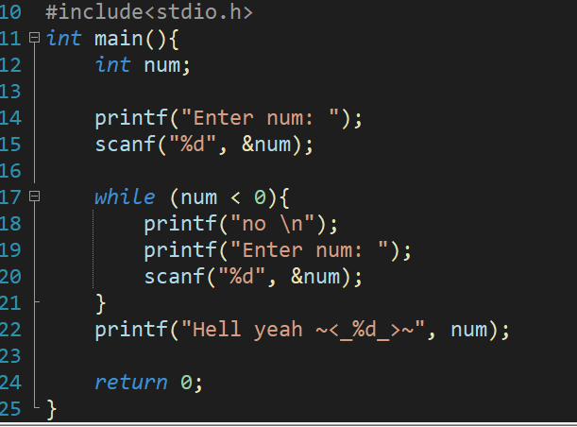

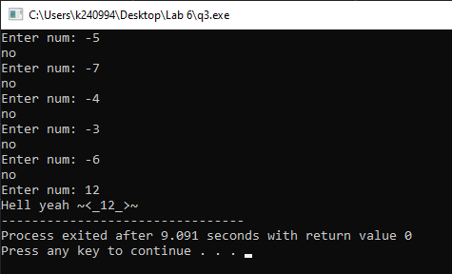

Q4:

A While loop would be best as we do not know the number of iterations needed until the user enters the value 0.

#include<stdio.h>

int main(){

int value, sum =0, flag =0;

while(flag == 0){

printf("Enter a Value: ");

scanf("%d",&value);

sum += value;

if(value != 0){

printf("%d \n", sum);

}else{

flag = 1;

}

}

return 0;

}

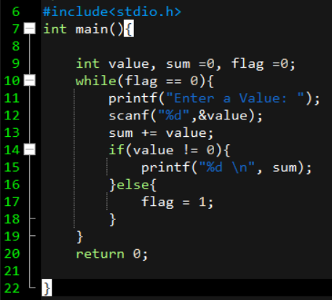

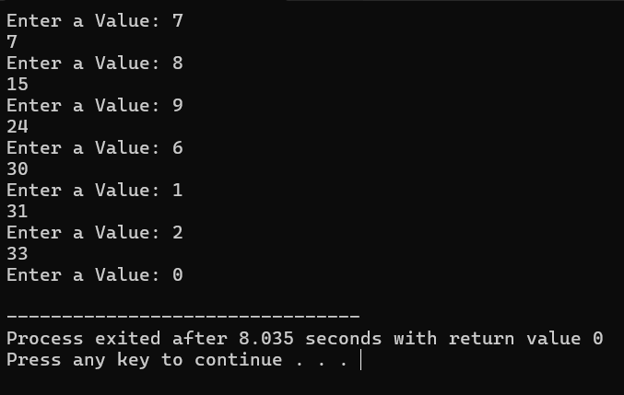

Q5:

#include<stdio.h>

void main(){

int i, value, flag = 0;

printf("Enter a number: ");

scanf("%d", &value);

for(i = 2; i < value; i++){

if(value % i == 0){

flag = 1;

}

}

if (flag == 0){

printf("The number is a PRIME number");

} else{

printf("The number is NOT a PRIME number");

}

}

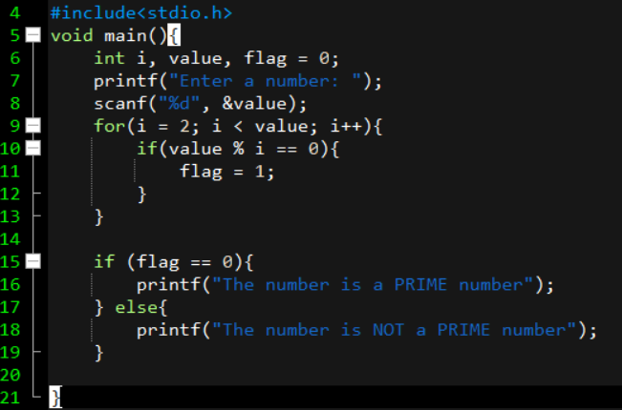

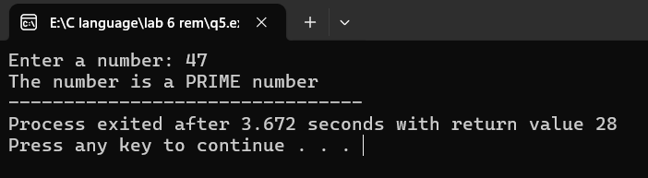

Q6:

/*

Using the above program integrate the number if it is a prime and print the Fibonacci

series till that number.

*/

#include<stdio.h>

void main(){

int i,j,temp = 1, value, flag = 0, t1 = 0, t2 = 1, nextTerm = 0;

printf("Enter a number: ");

scanf("%d", &value);

for(i = 2; i < value; i++){

if(value % i == 0){

flag = 1;

}

}

if (flag == 0){

printf("The number is a PRIME number\n");

} else{

printf("The number is NOT a PRIME number\n");

}

printf("Fabonacci series for %d terms: \n", value);

for (j = 1; j <= value; j++) {

if (j == 1) {

printf("%d ", t1);

continue;

}

if (j == 2) {

printf("%d ", t2);

continue;

}

nextTerm = t1 + t2;

t1 = t2;

t2 = nextTerm;

printf("%d ", nextTerm);

}

}

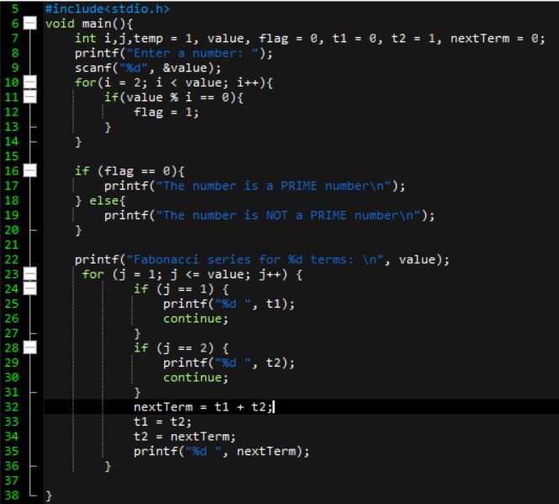

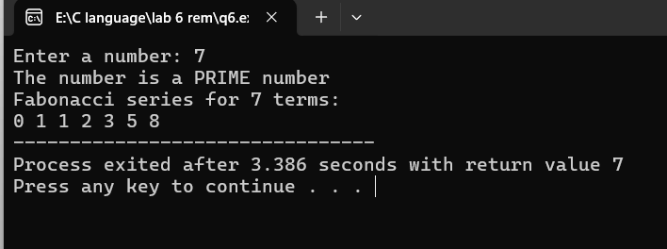

Q7:

#include<stdio.h>

void main(){

int input, original,remainder,result = 0;

printf("Enter the your number: ");

scanf("%d", &input);

original = input;

while (original != 0) {

remainder = original % 10;

result += remainder * remainder * remainder;

original /= 10;

}

if (result == input){

printf("This is an Armstrong number");

}else{

printf("This is NOT an Armstrong number");

}

}

